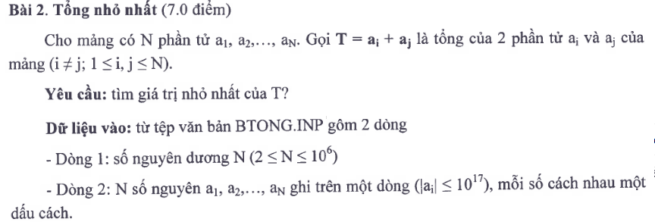
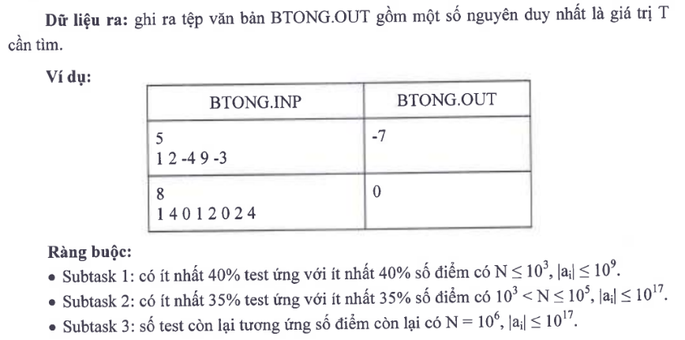
n = int(input())
a = map(int, input().split())

min1 = 10**30
min2 = 10**30

for x in a:
if x < min1:
min2 = min1
min1 = x
elif x < min2:
min2 = x

print(min1 + min2)

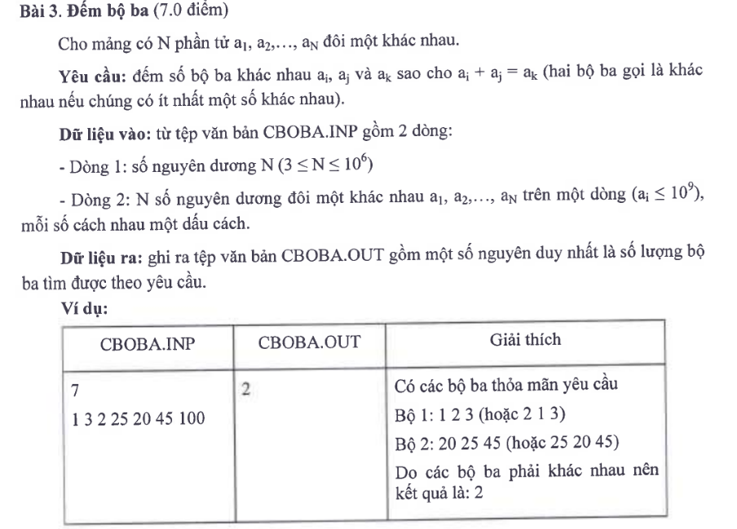
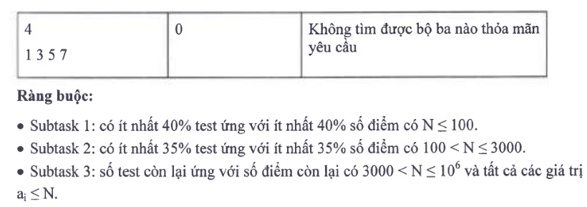

n = int(input())
a = list(map(int, input().split()))
a.sort()
count = 0
for k in range(n):
i = 0
j = k - 1
while i < j:
s = a[i] + a[j]
if s == a[k]:
count += 1
i += 1
j -= 1
elif s < a[k]:
i += 1
else:
j -= 1

print(count)

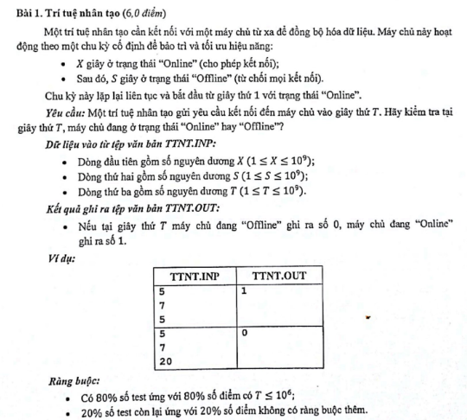
X = int(input())
S = int(input())
T = int(input())
print(1 if (T - 1) % (X + S) < X else 0)
